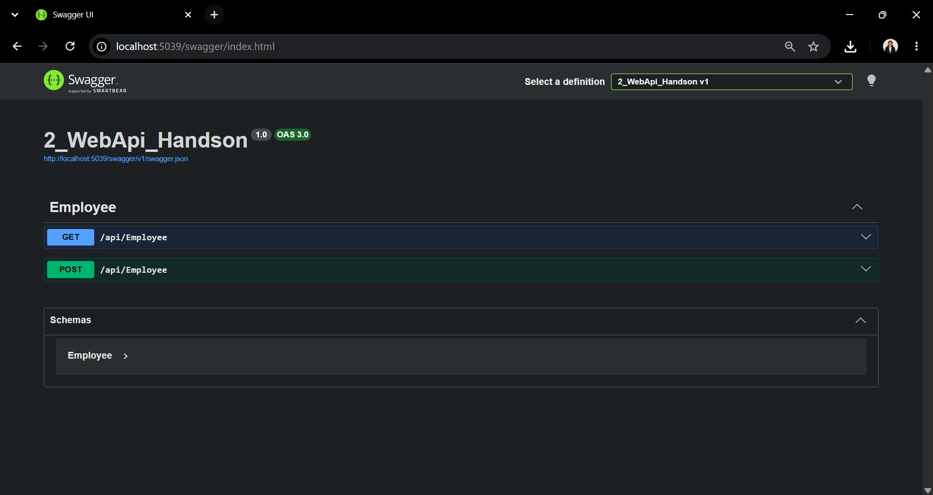
Figure 1: Swagger UI displaying the Employee Web API with GET and POST endpoints.

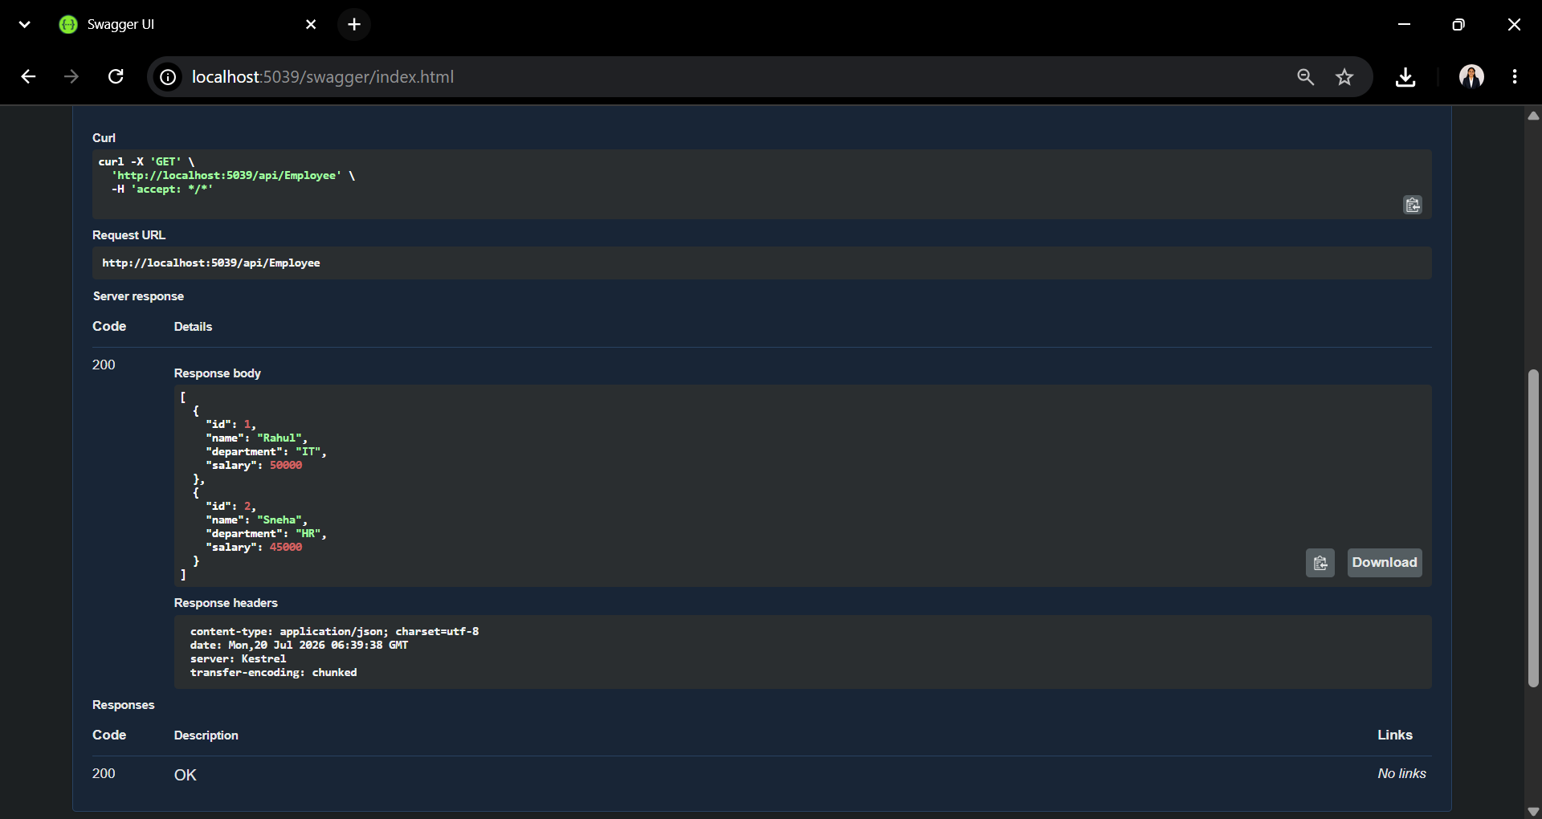
Figure 2: Successful execution of the GET request in Swagger displaying the Employee list.

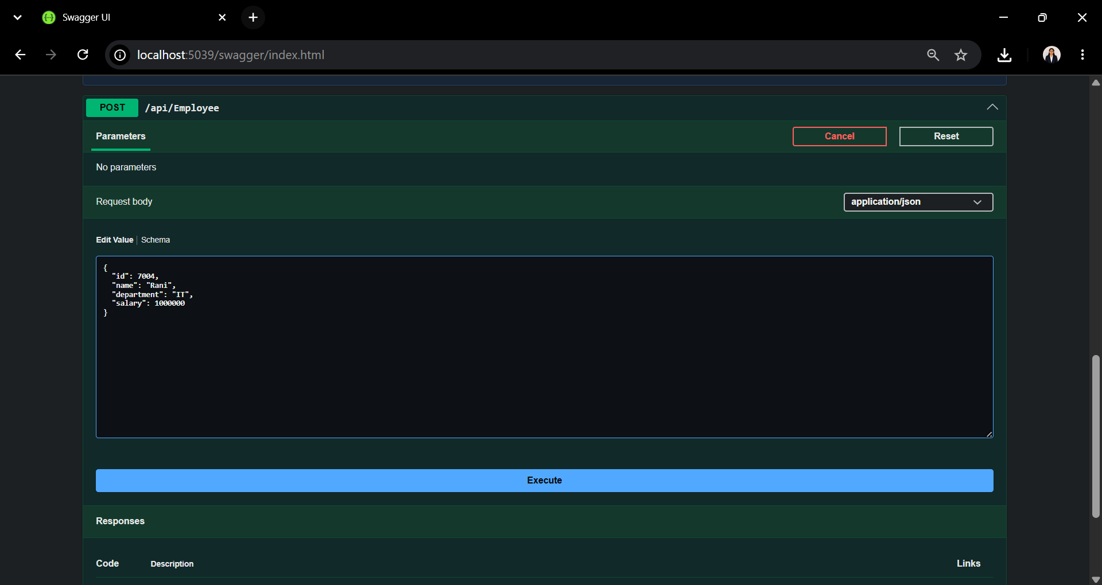
Figure 3: Entering employee details in the POST request body using Swagger.

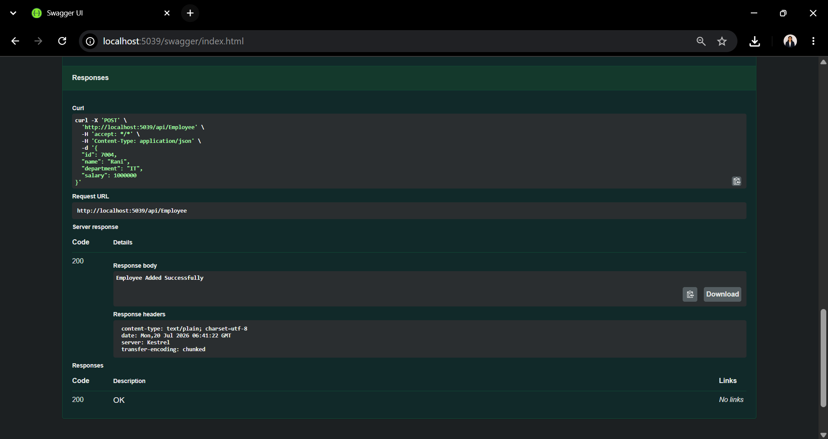
Figure 4: Successful execution of the POST request in Swagger showing the employee added successfully.

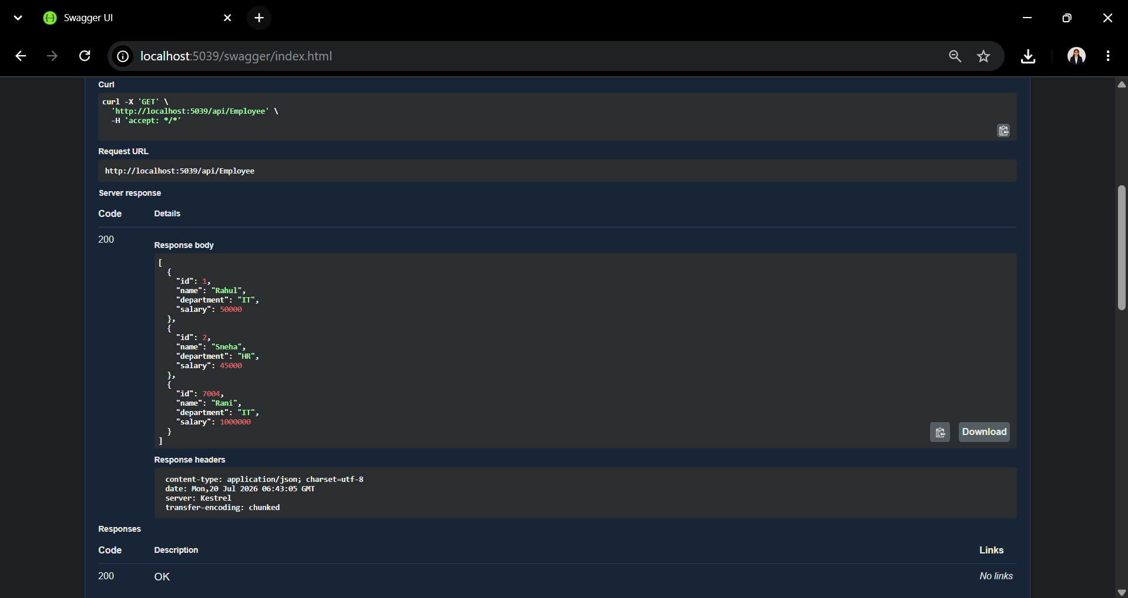
Figure 5: GET API response displaying the updated employee list after adding a new employee.

